XXX EURAGRI Conference
“The bio-economy – challenges and implementation – the research organizations’ perspective”
co-hosted by the Estonian Ministry for Rural Affairs and the Estonian University of Life Sciences
Tartu, 25 – 27 September 2016
Estonian University of Life Sciences, Tartu, Estonia
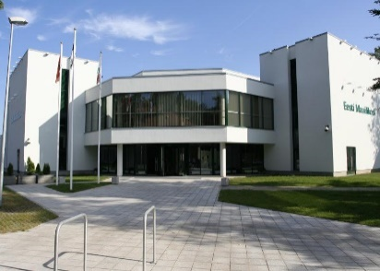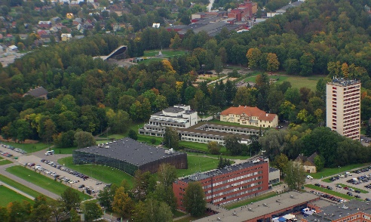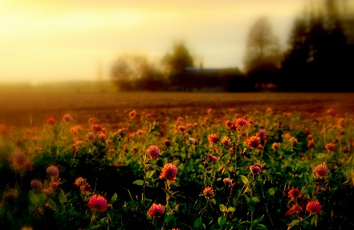

The agro-food sector, as an integral part of the bio-economy, serves a multitude of functions, sometimes with conflicting implications. In order to maintain a competitive sector that also values environmental services and rural development, the continuous development and application of new technologies but also new organizational forms will be crucial. Both will also transform the sector.
What are the implications for the research organisations working within this context? What is their role in implementing bio-economy strategies? What is the impact on research? Are changes necessary with regard to curricula and teaching methods concerning university education?
EURAGRI and the Estonian University of Life Sciences invite you to reflect on the opportunities and challenges encountered in implementing a bio-economy strategy. We offer an informative and inspiring dialogue for all actors interested to exchange ideas, experiences, challenges and opportunities related to structural and strategic changes as a consequence of a developing bio-economy and to diffuse the shared knowledge for future food for thought.

Sunday 25 September 2016
19:00 – 21:00 Welcome reception

Monday 26 September 2016
08:30 – 09:00 Welcome and registration
09:00 – 10:00 Welcoming words
- Estonian University of Life Sciences - rector Mait Klaassen
- Estonian Minister of Rural Affairs Mr Urmas Kruuse
- Welcome address by the European Commission - John BELL, Director of DG Research & Innovation
- Address Slovakian Presidency - Mrs Dana Peškovicova, Ministry of Agriculture and Rural Development of the Slovak Republic
- Welcome address by Pascal Bergeret, president of the EURAGRI

10:00 – 10:30 Key note: Reflections on opportunities and challenges in implementing a bio-economy strategy - a life sciences university’s perspective.
Ülle Jaakma, Vice-rector, Estonian University of Life Sciences

10:30 - 11:00 Coffee break
11:00 – 11:30 Reporting from EURAGRI workshops

- Big data in agriculture: consequences for research and research organizations
Christian Huyghe, INRA
- The human dimension in the bio-economy framework – applications with relevance for the broad field of agriculture
Uno Svedin, Stockholm University; Bettina Heimann EURAGRI

11.30 – 12.30 Panel: The bio-economy – new demands for research organizations in agro-food and life sciences sector

- Teagasc Technology Foresight 2035 Report (Gerry Boyle, Teagasc)
- Interdisciplinary in higher education for the bio-economy (Gerlinde van Vilsteren, Centre for bio-based Economy, University Wageningen)
- Research institutional restructuring (Markku Järvenpää, National Resources Institute, Finland.)
- Reconciliation and trade-offs, productivity – ecosystem services (Hervé Guyomard, INRA)
12:30 – 14:00 Lunch
14:00 – 18:30 Field trip
- Le Coq brewery (confirmed) (http://www.alecoq.ee/en )
- Grüne Fee Eesti AS - greenhouses (vegetables and spices) (tbc.) usually they do not allow groups into their greenhouses. Promised to give an answer within some days.
19:00 – 19:45 General Assembly of EURAGRI (members only)
Hopefully to be held on Sunday/and-or guided tour Tartu
20:00 Conference dinner Tartu

Tuesday 27 September 2016
09:00 – 10:00 Keynotes from
- Experience in growing of woody biomass from plantations - R&D and practice.
Mindaugas Šilininkas, R&D Euromediena (http://euromediena.com)
- The role and the impact of university research on the bio-economy, Prof. Dr. Salasan , Vice-Dean of the Agricultural Management Faculty, Romania
- 09.40-10.00 Untapping regional bioeconomy potentials with BERST toolkit – functionalities and limitations - Prof. Luka Juvančič, University of Ljubljana, Slovenia, Myrna van Leeuwen, Wageningen Economic Research, Holland.

10:00 – 10:30 Coffee break
10:30 – 12:30 Parallel discussion groups
- Technological development focus food production in bio-economy, cascading
(Isabel Roldan, ILVO)
- Education for complex problem solving
(Lone Krogh, Aalborg University)
- Research institutional restructuring
(Pascal Bergeret, IAMM)
- Productivity – environmental services
(Angelika Wurbs, ZALF)
12:30 – 14:00 Lunch
14:00 – 15:00 Reports from the parallel discussion groups
15:00 – 15:30 Coffee break
15:30 – 16.00 Conference wrap-up and conclusions Ülle Jaakma, Vice-rector, Estonian University of Life Sciences

16.00 Closing of conference, Pascal Bergeret, President EURAGRI

